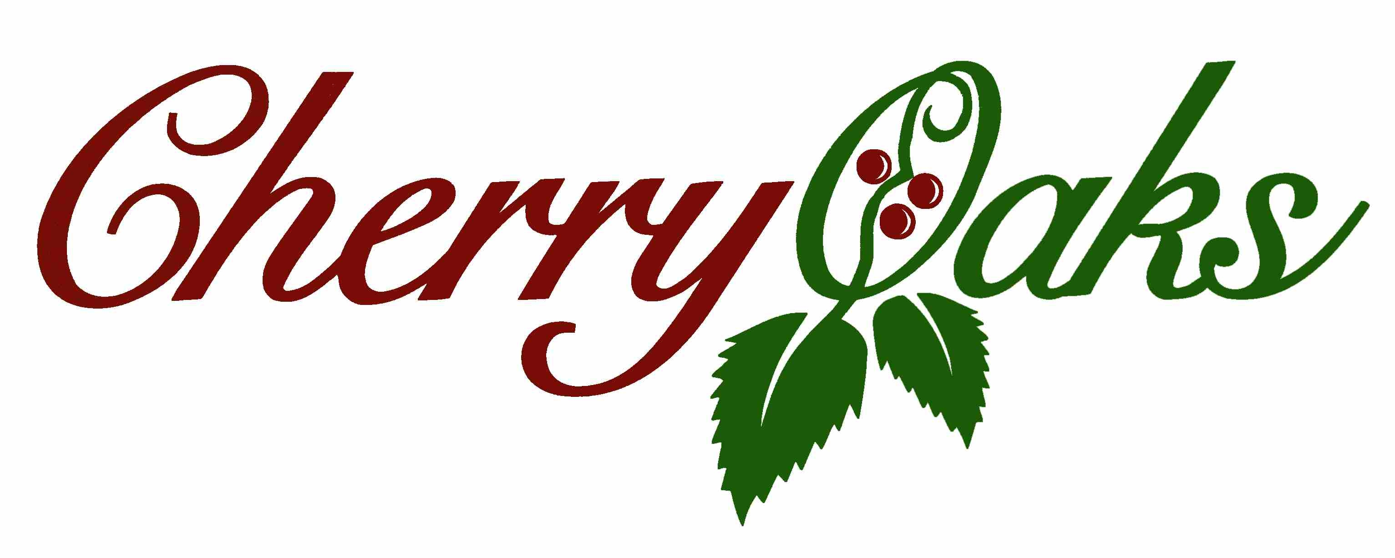
Cherry Oaks Golf Course would like to invite your child to join our 2022 Junior Golf Program!
The program will be instructed by Irv Schueller. Irv is the golf coach at Andale and Garden Plain High Schools.
2022 Junior Golf
$75.00 per child
Registration will be limited to the first 50 paid juniors.
Juniors will learn the fundamentals of golf including etiquette and rules through 4 days of lessons, contests and fun.
There will be 2 play days where the kids will be on the course as well!
Lessons: Ages 8-11 June 20th, 21st, 22nd and 23rd
From 8:00 to 9:15 a.m.
Lessons: Ages 12-17 June 20th, 21st, 22nd and 23rd
From 9:30 to 10:45 a.m.
2022 Play Days –Wednesday June 29th and Thursday June 30th
We will have a shotgun start on play days. We will tee off at 8:00. We will need parents to accompany the younger groups.
A cart will be provided for the parents. The junior golfers are NOT allowed in the cart.
When registering, please provide a cell number so Irv can text in case of emergency or to make changes due to weather.
Please call Cherry Oaks Golf Course with questions and to sign up. 316-540-0133

